**What vaccinations does my goat need?**

At Golden Valley Goats our pregnant does all receive a Glanvac 3 in 1 vaccine 4 weeks prior to their kids being born. This helps protect their unborn kids.

Glanvac 3 targets Cheesy Gland (CLA), Tetanus and Pulpy Kidney. Sometimes we use Glanvac 6 if we can’t source Glanvac 3. Glanvac 6 provides protection against a greater number of diseases, but we were advised that better protection against the first three is achieved by using a smaller number of antigens. Talk to your vet to confirm that the extra pathogens covered in Glanvac 6 are not prevalent in your area (eg, liver fluke).

Our kids are given a dose of Glanvac 3 when they turn **4 weeks old** and again when they are **8 weeks old**. From then on they are vaccinated **every 6 months**. The dose is 1ml per goat, regardless of age or size.

When you collect a goat from us we can show you how to vaccinate your goats yourself. It is a subcutaneous injection so administered just under the skin. Alternatively you may prefer your vet to administer future vaccinations.

In many cases goats will develop a small sterile abscess at the vaccination site. It is nothing to worry about and is caused by an adjuvant in the vaccine that helps it to be more effective.

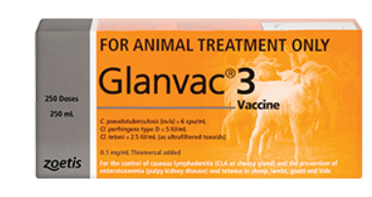

Disclaimer: I am not a vet. This information is based on the husbandry procedures that I use with my goats. Talk to your vet to get current best practice information and to discuss the risks of vaccination.